Accessing Databases using code

Accessing Databases using Java

Set up SQL server for JDBC
In the following lab you'll practice creating a new user for MS-SQL using SSMS. You will then set the right this new should have and then use the user name and password in code to connect and extract data from a database using Java.

Create the database needed for this lab
- In this lab you will require a database called QAStore.
- To install this database, double-click on the file QAStore.sql in the Resources folder.
- Microsoft Server Management Studio (SSMS) app will open.
- Login as the default Windows user (you!)
- Click on the Execute button (or press F5) to install the QAStore database.

Prepare and configure MS-SQL
- Start SSMS (if not started already) and then right mouse click on the server
- Select Properties
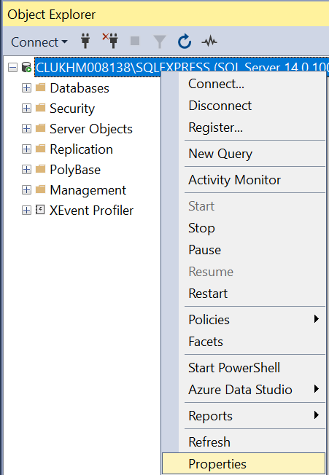
- Select Security
- Select SQL Server and Windows Authentication mode
- Click OK
- Close SSMS because you're going to make more changes
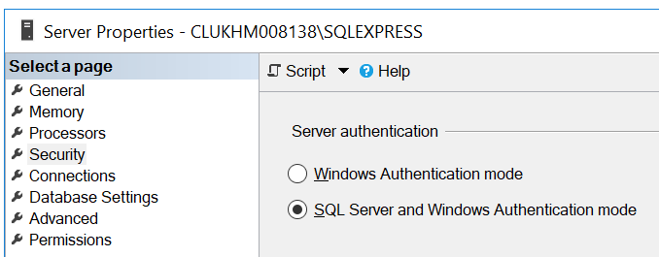
- In Windows, type the word compmgmt.msc in the search box.
This will run the Computer management application.
- Select 'Services and Applications' > 'SQL Sever Network Configuration'
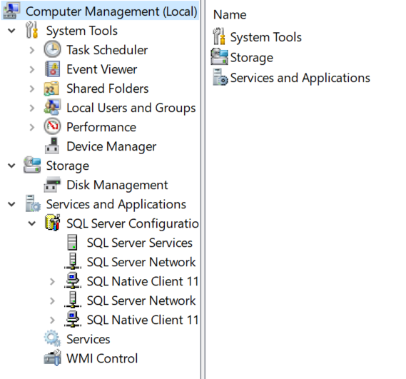
- Double click the SQL Server Network menu from the list on the left
- Double click the Protocols for SQLEXPRESS (on the right hand side)
- Double click the TCP/IP menu from the right hand side
- Double click on the Enabled attribute to change its state to Yes( Enabled)
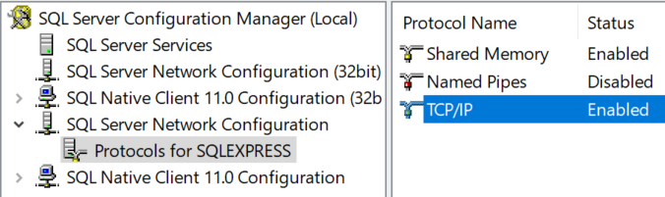

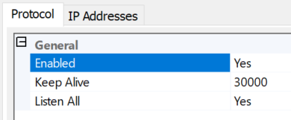

- Click on the IP Addresses tab
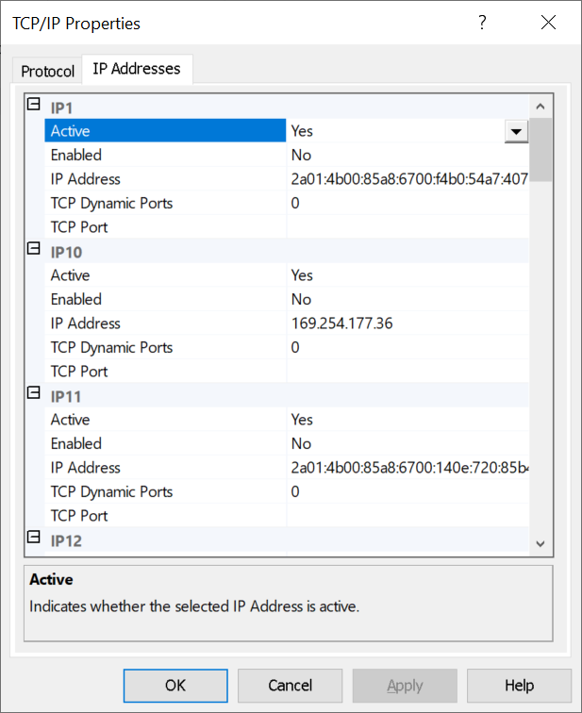
- Scroll to the bottom of the list and take a note of the IPAll TCP port 1433
(could be different) which you'll need when you construct a connection string in your Java code later on.

Restart the SQL Service
- In windows, type services 
- Find the SQL Server service and restart it
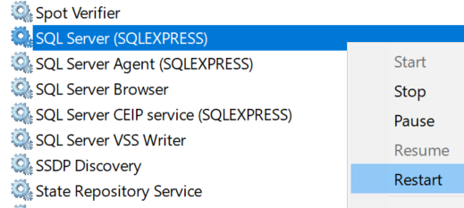

Create a user in SSMS
Next we'll create a user for your application with enough rights to access a database of your choice.
- Create a new login by right mouse clicking on the Security tab
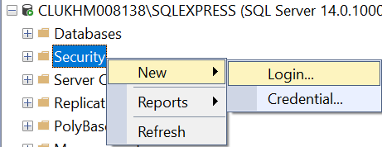
- Type the user details and uncheck 'User must change password at next login'.
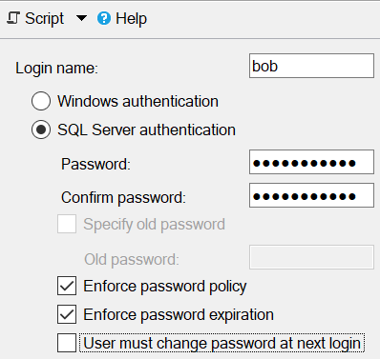
- Grant rights by selecting the "User Mapping" item on the left
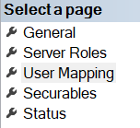
- Select the qastore database and as assign as many rights as needed.
Here we've selected db_owner rights but in real life you may select fewer rights.
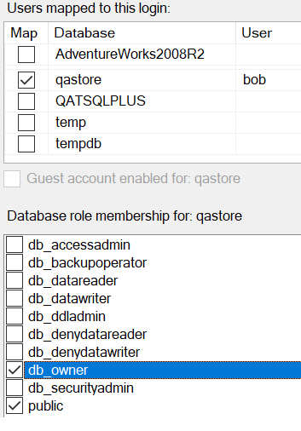
- Click OK
- Now you need to disconnect and reconnect the database
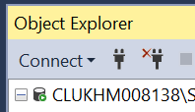
- Try the new user when you connect back again to test the new login.
- You're now ready to use this new user's credentials in code.

Write the code
In this section you'll extract rows from the qastore database
- Before you start coding you'll need the JDBC library which you can download by clicking here https://repo1.maven.org/maven2/com/microsoft/sqlserver/mssql-jdbc/8.3.1.jre14-preview/
You'll see all the supported database types on this page.
To save you downloading a driver we've included the mssql-jdbc-8.3.1.jre14-preview.jar
file in your course material folder.
- You'll now need to create an application and use this jar file. Please follow the step by step instructions below.

- Start eclipse
- Select a folder where you want to save your project
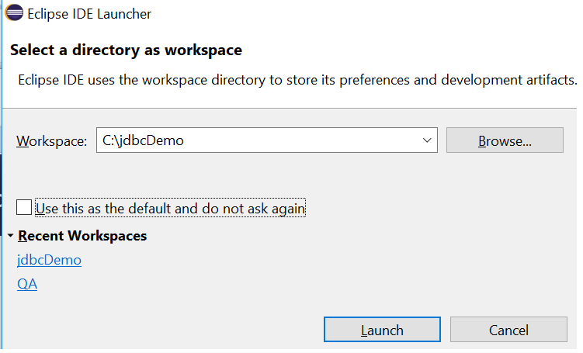
- Select File > New > Java Project
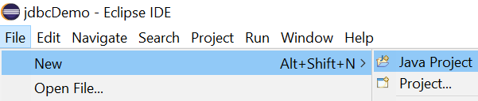
- Type a project name and then click the Finished button
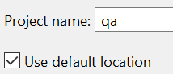
- Click the Create button in the next dialog
- You can close the Welcome page
- Click on the package explorer button (small icon on top left). Alternatively select the following menus
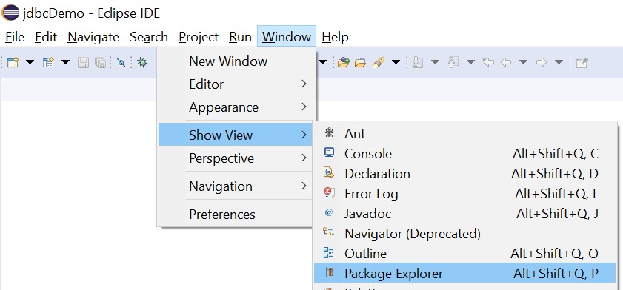
- Expand the nodes
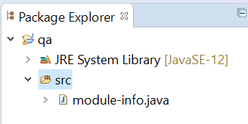
- Right mouse click on the src node and then select the New > Class menus
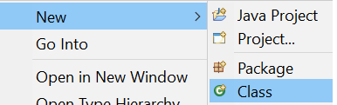
- Select name Program (or any name you like, first letter in caps)
and make sure you select the public static void main(String[] args) check box.
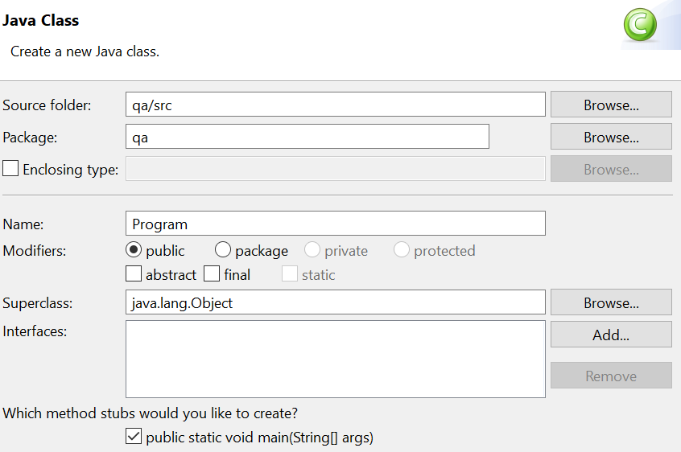
- Click Finished
- Right mouse click on your project (here is qa) and then select Properties
- Select the following options and tabs in the next dialog
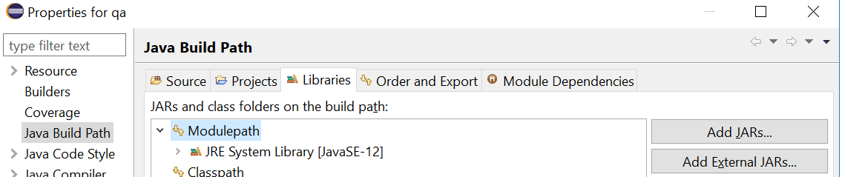

- Click the Add External JARs… button
- Find the jar file provided (mssql-jdbc-7.1.2.jre8-preview.jar) and then
click Apply and Close
- Back in the src node, click the Program class to display its code
- Replace the main() method's code with
public static void main(String[] args) throws Exception{
String connectionUrl = "jdbc:sqlserver://localhost\\SQLEXPRESS:1433" + ";databaseName=qastore;user=bob;password=password123";
Connection connection = DriverManager.getConnection(connectionUrl);
String sql = "SELECT company_name FROM company";

Statement statement = connection.createStatement() ;
ResultSet resultSet = statement.executeQuery(sql);

while ( resultSet.next() ){
System.out.println( resultSet.getString(1));
}
connection.close();
}

- The code sample seems to have failed with errors! To get rid of these just click on the class name Connection in code and then press Ctrl-1 (control 1)
You can now double click the option "Import 'Connection' (java.sql)…" to resolve the Connection error.
Click Ctrl-1 on other errors and then select the Import option
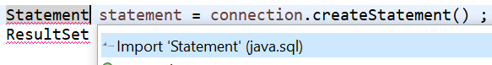
- After all the errors are resolved, save your code by pressing Ctrl-s
- Run your code to see it working by pressing Ctrl-F11

(Optional and if you have plenty of time)
Create parameterised queries
- Create another class called Program2
Right mouse click on the src node and then select New > Class

- Copy the following code to the class.
This is a complex piece of code. Please study the code and see if it makes sense.

private static void example2(Connection connection) throws Exception {
String sql = "SELECT * FROM company WHERE county = 'London'" ;

Statement statement = connection.createStatement() ;
ResultSet resultSet = statement.executeQuery(sql);
resultSet.setFetchSize(2); // optional

String id, name, county;
StringBuilder out = new StringBuilder() ;
while ( resultSet.next() ){
id = resultSet.getString(1);
name = resultSet.getString(2) ;
county = resultSet.getString("county") ;
out.append(String.format("Id: %-7s Name:%-25s County:%s\n", id,name,county) );
}
connection.close();
System.out.println(out.toString());
}

Create Parameterised queries
To protect your system against SQL Injection attacks and for a better constructed SQL statements always use parameterised queries. In the above example the word 'London' was inserted into a SQL string. Please copy and run the following code. You'll find this method a lot easier when you've multiple parameters.
private static void example3(Connection connection) throws Exception {
String sql = "select company_no, company_name, post_code, county " + "from company WHERE county=? AND post_code like ?" ;
PreparedStatement statement = connection.prepareStatement(sql) ;
// 'London or 1=1; --' will not return any result!
statement.setString(1,"London"); // the first ? (city)
statement.setString(2,"N%"); // the second ? (contactName)

ResultSet resultSet = statement.executeQuery();

String company_no, company_name, post_code, county;
StringBuilder out = new StringBuilder() ;
while ( resultSet.next() ){
company_no = resultSet.getString(1);
company_name = resultSet.getString(2) ;
post_code = resultSet.getString(3) ;
county = resultSet.getString("county") ;

out.append(String.format("No: %-7s Name:%-25s County:%s Post_Code:%s \n", company_no, company_name, county, post_code) );
}
System.out.println(out.toString());
}
Now try inserting a new row into the customers table
Hint: use the statement's executeUpdate() method

Try to update the row which you just created
See if you can delete a row.

** End **

